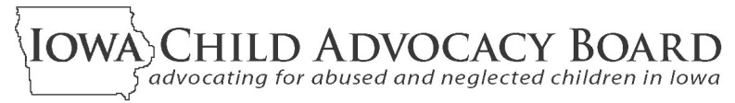
2010 ANNUAL REPORT

The Iowa Child Advocacy Board (ICAB) is an independent board appointed by the Governor of Iowa to provide for citizen involvement in child welfare issues. ICAB oversees two volunteer child advocacy programs designed to help protect Iowa children and their best interests while they are being served by the child welfare system.
FCRB volunteers serve on local community boards that meet regularly to review case plans, hear from all interested parties,
and provide the Court and DHS with their findings and recommendations about the safety, well-being and permanency of children from their communities who are in foster care.

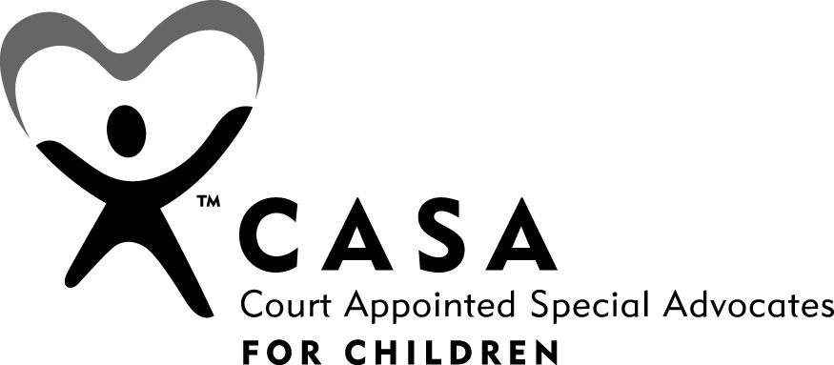

CASA volunteers are appointed by the Court to advocate for a specific child. Throughout the life of this
child’s case, they meet with the child, parents, attorneys,
DHS workers, service providers, teachers and others.
CASA volunteers regularly report to the Court about the child’s situation and offer recommendations to help assure the child’s best interests are being met.

fzzzxzxc

In Calendar Year 2010

- More than 1,100 volunteers from all over Iowa spent tens of thousands of hours working to assess and help improve the situations of abused and neglected children and their families in Iowa’s child welfare system.

- 1,550 abused or neglected Iowa children had a CASA volunteer assigned to them.

- Foster Care Review Boards held 3,355 case-level reviews of children in foster care.

- The monetary value of FCRB and CASA volunteers’ time and resources to provide a safety net for abused and neglected children was estimated to be over $2.58 million.

- The Department of Management reduced ICAB’s budget by $240,000 in December of 2010 as a part of an $84 million state budget reduction authorized during the 2010 Session of the Iowa General Assembly. The beginning months of 2011 saw ICAB staff reductions, office closings and other budget reduction measures. These reductions will be affecting the number of volunteers that can be supported and the number of children whose cases will receive FCRB or CASA volunteer involvements.

Findings and Recommendations – Focus on Permanency
For this 2010 report, ICAB is highlighting the importance of achieving permanency for all children in Iowa’s child welfare system. Children deserve to be connected to adults who will provide them with legal family membership, safety, stability, unconditional love, and lifelong support. Achieving this for kids in Iowa’s child welfare system is often a difficult and complicated undertaking that requires coordinated efforts by many individuals, organizations and officials. In 2009 and 2010, ICAB staff participated in an effort to examine the challenges faced by children, parents and other family members, DHS, the Court, service providers, foster and adoptive parents and others in achieving permanency for children under the State’s supervision, custody or guardianship. This collaborative planning effort led to the issuing of “Iowa’s Blueprint for Forever Families” in early 2011.
IOWA CHILD ADVOCACY BOARD•LUCAS BUILDING•321 E 12 ST•DES MOINES, IA 50319-0083•866-448-4608• cab@dia.iowa.gov

ICAB has endorsed “Iowa’s Blueprint for Forever Families” and urges all policy makers, system officials, service providers, community organizations and the general public to read it and answer its challenge to find ways they can improve permanency outcomes for our children. Please read or download it here: Blueprint.
Learn more about the CASA and FCRB programs and the opportunities they provide for concerned Iowans to serve their communities and help abused and neglected children and their families. Go to: http://childadvocacy.iowa.gov
fzzzxzxc

