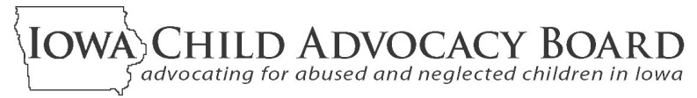
2011 ANNUAL REPORT

The Iowa Child Advocacy Board (ICAB) is an independent board appointed by the Governor of Iowa to provide for citizen involvement in child welfare issues. ICAB oversees two volunteer child advocacy programs designed to help protect Iowa children and their best interests while they are being served by the child welfare system.
FCRB volunteers serve on local community boards that meet regularly to review case plans, hear from all interested parties,
and provide the Court and DHS with their findings and recommendations about the safety, well-being and permanency of children from their communities who are in foster care.

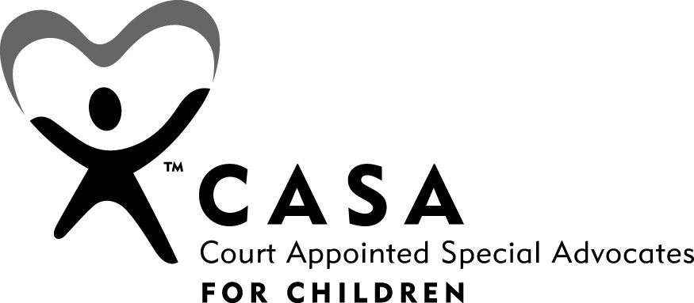

CASA volunteers are appointed by the Court to advocate for a specific child. Throughout the life of this
child’s case, they meet with the child, parents, attorneys,
DHS workers, service providers, teachers and others.
CASA volunteers regularly report to the Court about the child’s situation and offer recommendations to help assure the child’s best interests are being met.

fzzzxzxc

Child Advocacy Board Operations in Calendar Year 2011

- Nine hundred and ninety-six volunteers from all over Iowa spent over 49,000 hours assessing and assisting situations of abused/neglected children and their families in Iowa’s child welfare system. The monetary value of FCRB and CASA volunteers’ time and resources to provide a safety net for abused and neglected children in 2011 is estimated to be over $2.3 million. And, the value of these volunteers’ efforts grows over time as cases they have assisted are successfully resolved and potential long-term fiscal and social costs are avoided.

- In December of 2010, outgoing Department of Management officials reduced ICAB’s Fiscal Year 2011 (7/1/2010-6/30/2011) budget by $240,000 as part of an $84 million state budget reduction authorized during the Iowa General Assembly’s 2010 Session. Staff layoffs, office closings and other budget reduction measures were implemented to address what was more than a 16% cut to ICAB in the last six months of FY2011.

- In June, 2011, the Legislature and Governor appropriated FY2012 funding for ICAB programs equal to FY2011 levels after the mid-year cut. This prevented further cuts in calendar year 2011, but did require the continuation of the reductions already made in administrative support for the CASA program and a major downsizing and redesign of the FCRB program.

- Despite the budget cuts, the CASA program continued its activities throughout the state. Over 1,536 abused and neglected children had a CASA volunteer assigned to them during 2011. No child who had a CASA volunteer working for them before the 2011 budget cuts lost their CASA because of the cuts. Recruiting new CASA volunteers continued and remains ongoing.

- During 2011, local FCRB volunteers held 2,054 reviews of children in foster care. Local boards continued to be in place in all of the Department of Human Services’ service areas. However, their number was reduced from 62 to 29 boards, and not all children in foster care are being reviewed in all areas served by local boards. For 2012, it is projected that the number of reviews will see a reduction of from 30-40% (from the 3,355 reviews conducted in 2010, before the budget cut).

- When all cases in an area are not able to be reviewed, locally designed case selection criteria have been established with input from DHS, judges and local FCRB members. This approach was designed to strategically provide local board reviews of cases with the greatest need or likelihood of benefiting from a review, or to help address systemic issues of concern.

- Various aspects of the 2011 FCRB redesign, including the selection of cases to review and the frequency, timing and focus of the reviews, will further evolve in 2012. Input will continue to be sought from the Court, DHS and others to help steer ongoing program quality improvement activities of benefit to the children, families, service providers and officials involved in Iowa’s child welfare system.

Findings and Recommendations

1. Focus on Permanency

ICAB urges all policy makers, system officials, service providers, community organizations and the general public to read the “Iowa’s Blueprint for Forever Families” and answer its challenge to find new ways they can improve permanency outcomes for our children.

For this 2011 report, ICAB is again stressing the importance of achieving permanency for all children in Iowa’s child welfare system. All children deserve to be connected to adults who will provide them with legal family membership, safety, stability, unconditional love, and lifelong support. Achieving this for kids in Iowa’s child welfare system continues to be a difficult and complicated undertaking that requires coordinated efforts by many individuals, organizations and officials.

In ICAB’s 2010 Annual Report, there was a description of its support of “Iowa’s Blueprint for Forever Families,” a planning framework designed to encourage and assist steps to help improve permanency outcomes for children under the State’s supervision, custody or guardianship. In 2011, CASA and FCRB program-specific “Blue Sheets” were created to identify specific action steps that can be taken by CASA volunteers and local FCRB members to help improve permanency outcomes for the children with whom they are involved.

The CASA and FCRB “Blue Sheets” were written in collaboration with the Court’s Children’s Justice initiative, DHS, Iowa Foster and Adoptive Parents Association, Coalition for Children and Family Services, Youth Policy Institute, Casey Program staff and others. Additional “Blue Sheets” and related materials are being prepared by these groups to offer specific guidance to judges, DHS workers, attorneys, foster parents, service providers and others to improve permanency outcomes for children in Iowa.

To view the Blueprint, click here: “Iowa’s Blueprint for Forever Families,”
To view the CASA Blue Sheet, click here: “Blue Sheet for CASA Volunteers”
To view the FCRB Blue Sheet, click here: “Blue Sheet for Foster Care Review Boards”

2. Program Improvement Plan for Iowa’s Child Welfare System

The Governor, General Assembly, Court and all affected officials and organizations are urged to acknowledge the importance of the goals and action steps of a DHS-led Program Improvement Plan; to help monitor its progress; and, to respond to policy, budget and system coordination requests that surface during its implementation.

All states are required to periodically participate in a federally conducted Child and Family Service Review (CFSR) to determine their level of compliance with system performance standards. Non-compliance with these standards can lead to penalties and a reduction in federal funding for child welfare programs. Iowa’s recent (August, 2010) CFSR findings indicated a need for improvements in a number of areas. This has been the case in all states. In Iowa, the following outcomes and systemic factors are those requiring improvements:

- Absence of Maltreatment Occurrence
- Absence of Maltreatment of Children in Foster Care
- Timeliness and Permanency of Reunification
- Timeliness of Adoptions
- Permanency for Children in Foster Care for Extended Time Periods
- Placement Stability
- Quality Assurance System (systemic factor)
- Service Array and Resource Development (systemic factor)

Working with federal officials and others, the Department of Human Services has responded to Iowa’s CFSR findings through the development of a Program Improvement Plan (PIP) approved by the federal government in October, 2011. As described in the PIP, strategies designed to address areas needing improvement include:

Family Engagement:
- Caseworker Visits: Increase quality and frequency of caseworker visits with parents and children;
- Collaboration and Partnership with External Stakeholders: Expand Responsible Fatherhood and Non-Custodial Parent (NCP) initiative; Expand Parent Partners

Permanency Planning:
- Family Team Decision-Making Meetings (FTDM): Increase effective use and facilitation of FTDMs to improve family’s engagement in case planning;
- Collaboration and Partnership with External Stakeholders: Improve permanency for youth; Expand foster care and foster care alumni youth involvement;
- Family Interaction (FI): Improve integration of FI practice; increase identification, location, and engagement of relatives and other supports in FI practice

Services Provision:
- Collaboration and Partnership with External Stakeholders: Strengthen Community Partnership for Protecting Children (CPPC); Align services with safety, permanency, and well-being outcomes; Support development of an array of children’s mental health services to improve capacity and access; Enhance ability to address educational needs of children; Improve cultural competency and responsiveness of the child welfare system

Quality Assurance (QA) System:
- Implement a reliable and valid QA system for case reviews to effectively monitor progress and make changes in strategy based on case reading data.
- Supervision – Support supervisors in practice to enhance frontline practice around safety, permanency, and well-being outcomes

3. DHS Worker Caseloads

All parties involved with the DHS-led Program Improvement Plan now underway are urged to maintain a focus of concern on caseload sizes in the months ahead and throughout the coming fiscal year. The Human Services Council, Governor and General Assembly are urged to support an increase in the number of DHS case workers if caseload sizes prove to be an obstacle while implementing the system improvement steps.

In 2006 and 2007, ICAB recommended increasing the number of DHS case workers and reducing caseload sizes to better implement system policies and improve the outcomes of Iowa’s child welfare system. In the years since then, state and national economic downturns and concerns have dominated state governments’ budget planning. DHS, other state and local agencies and the Court have had to find ways of continuing their operations with fewer dollars. Although efficiencies, new approaches, and other steps have occurred in response to budget reductions during the last several years, concerns over DHS caseload sizes remain.

Within the Program Improvement Plan described above, the size of DHS caseloads is identified as a potential barrier to accomplishing some of the system improvements laid out in the approved plan. In response, work groups and planning activities have been designed to take worker caseload sizes into account as strategies are further refined and implemented.

Learn more about the CASA and FCRB programs and the opportunities they provide for concerned Iowans to serve their communities and help abused and neglected children and their families. Go to: http://childadvocacy.iowa.gov
IOWA CHILD ADVOCACY BOARD•LUCAS BUILDING•321 E 12 ST•DES MOINES, IA 50319-0083• cab@dia.iowa.gov

