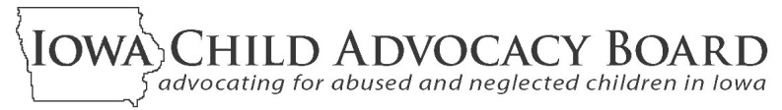

2012 ANNUAL REPORT

The Iowa Child Advocacy Board (ICAB) is an independent board appointed by the Governor of Iowa to provide for citizen involvement in child welfare issues. ICAB oversees two volunteer child advocacy programs designed to help protect Iowa children and their best interests while they are being served by the child welfare system.
FCRB volunteers serve on local community boards that meet regularly to review case plans, hear from all interested parties,
and provide the Court and DHS with their findings and recommendations about the safety, well-being and permanency of children from their communities who are in foster care.

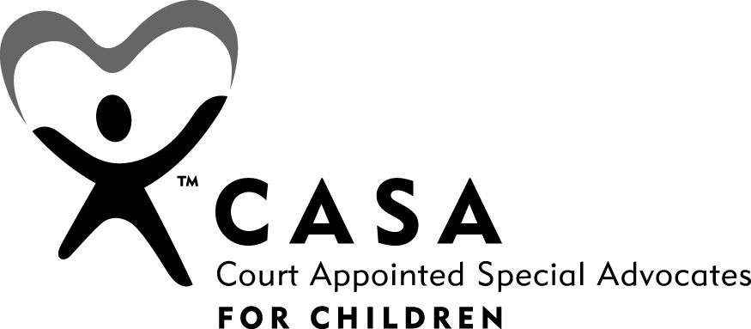


CASA volunteers are appointed by the Court to advocate for a specific child. Throughout the life of this
child’s case, they meet with the child, parents, attorneys,
DHS workers, service providers, teachers and others.
CASA volunteers regularly report to the Court about the child’s situation and offer recommendations to help assure the child’s best interests are being met.

fzzzxzxc

Child Advocacy Board Operations in Calendar Year 2012

- In the past year 990 volunteers from all over Iowa spent nearly 49,000 hours assessing and assisting situations of 2,958 abused/neglected children and their families in Iowa’s child welfare system. The monetary value of FCRB and CASA volunteers’ time and resources to provide a safety net for abused and neglected children in 2012 is estimated to be approximately $2.3 million. And, the value of these volunteers’ efforts grows over time as cases they have assisted are successfully resolved and potential long-term fiscal and social costs are avoided.

- In July, 2011 ICAB implemented a redesigned network of support to CASA and FCRB volunteers. Budget cuts made in the middle of FY2011 brought with them the need for staff layoffs, office closings and other budget reduction measures to address what was more than a 16% cut to ICAB in the last six months of FY2011. Funding appropriated for FY2012 equaled FY2011 levels after the mid-year cut. While implementing the FY2011 cuts, planning was underway to surface in FY2012 with a redesigned service system with the goals of maintaining CASA caseload sizes and altering FCRB processes to review as many cases as possible with the reduced funding level.

- Despite the reduced resources, the CASA program continued its activities throughout the state. Over 1,530 abused and neglected children had a CASA volunteer assigned to them during calendar 2012. No child who had a CASA volunteer working for them before the 2011 budget cuts lost their CASA because of the cuts. Recruiting new CASA volunteers continued and remained strong in calendar 2012.

- During 2012, local foster care review boards continued to be in place in all of the Department of Human Services’ service areas. The 29 local boards held 2,219 reviews of 1,427 children in foster care in the past year. Not all cases of children in foster care were reviewed, and planning for the planning of the FCRB redesign had anticipated this and included soliciting input from local board members, DHS and judges across the state were ongoing to help guide the selection of as many cases as possible.

- Since the beginning of 2012, ICAB has been assessing its redesigned FCRB structure and making adjustments when possible to increase the number of children’s cases that can be reviewed. Input is being sought and discussions involving local board members, judges, DHS and others will be taking place to help steer ongoing program quality improvement activities of benefit to the children, families, service providers and officials involved in Iowa’s child welfare system. Adding value to the reviews for judges, DHS and the families involved, along with increasing the number of children’s case being reviewed is a priority goal of ICAB in the months ahead.

Findings and Recommendations

1. Program Improvement Plan for Iowa’s Child Welfare System

The Governor, General Assembly, Court and all affected officials and organizations are again urged to acknowledge the importance of the goals and action steps of a DHS-led Program Improvement Plan; to help monitor its progress; and, to respond to policy, budget and system coordination requests that surface during its implementation.

All states are required to periodically participate in a federally conducted Child and Family Services Review (CFSR) to determine their level of compliance with system performance standards. Non-compliance with these standards can lead to penalties and a reduction in federal funding for child welfare programs. As was reported in ICAB’s 2011 Annual Report, Iowa’s recent (August, 2010) CFSR findings indicated a need for improvements in a number of areas. This has been the case in all states. In Iowa, the following outcomes and systemic factors are those requiring improvements:

- Absence of Maltreatment Occurrence
- Absence of Maltreatment of Children in Foster Care
- Timeliness and Permanency of Reunification
- Timeliness of Adoptions
- Permanency for Children in Foster Care for Extended Time Periods
- Placement Stability
- Quality Assurance System (systemic factor)
- Service Array and Resource Development (systemic factor)

Working with federal officials and others, the Department of Human Services is now in its second year of a two year plan to respond to Iowa’s CFSR findings. The first year of this Program Improvement Plan (PIP), has proceeded according to plan, but it is too early to assess its success at improving the above-listed outcomes. As described in the PIP, strategies designed to address areas needing improvement include:

Family Engagement:
- Caseworker Visits: Increase quality and frequency of caseworker visits with parents and children;
- Collaboration and Partnership with External Stakeholders: Expand Responsible Fatherhood and Non-Custodial Parent (NCP) initiative; Expand Parent Partners

Permanency Planning:
- Family Team Decision-Making Meetings (FTDM): Increase effective use and facilitation of FTDMs to improve family’s engagement in case planning;
- Collaboration and Partnership with External Stakeholders: Improve permanency for youth; Expand foster care and foster care alumni youth involvement;
- Family Interaction (FI): Improve integration of FI practice; increase identification, location, and engagement of relatives and other supports in FI practice

Services Provision:
- Collaboration and Partnership with External Stakeholders: Strengthen Community Partnership for Protecting Children (CPPC); Align services with safety, permanency, and well-being outcomes; Support development of an array of children’s mental health services to improve capacity and access; Enhance ability to address educational needs of children; Improve cultural competency and responsiveness of the child welfare system

Quality Assurance (QA) System:
- Implement a reliable and valid QA system for case reviews to effectively monitor progress and make changes in strategy based on case reading data.
- Supervision – Support supervisors in practice to enhance frontline practice around safety, permanency, and well-being outcomes

2. A Differential Response System for Responding to Abuse and Neglect

The Child Advocacy Board applauds the goals of Iowa’s moving toward a differential response system for responding to reports of abuse and neglect. The Governor, General Assembly, Court and all affected officials and organizations are urged to consider the recommendations they have received to implement such a system and to approve action steps that result in a carefully monitored implementation.

The Iowa Department of Human Services recently issued “Differential Response Review -- Summary of Charge - House File 2226”. In this report, required by 2012 legislature in HF 2226, recommendations are offered to implement a differential response system to handle reports of child abuse and neglect. The new system would include two discrete responses to child abuse reports: the current assessment/investigative response and a new voluntary non-investigative response. Called a "Family Assessment Response" (FAR), the new response would not involve a determination of whether abuse occurred, and no names would be placed on the child abuse registry.

The report stresses the importance of assuring that decisions to offer a FAR response would be based on an assessment of the risk and safety of the child. The most serious cases of abuse would continue to be immediately handled through the current assessment/investigative response. Families’ acceptance of the new response and the services it would offer them would be voluntary. Non-acceptance, coupled with risk and safety findings, would trigger the current assessment/investigatory response.

The report on differential response (DR) notes that an increasing number of states - including Minnesota and Missouri - have adopted this new approach to responding to child abuse reports. The report stresses that DR offers a less adversarial response that better engages some families without compromising child safety. The DR approach rests on a basic premise that the varied nature of child abuse requires more flexible system responses.
IOWA CHILD ADVOCACY BOARD•LUCAS BUILDING•321 E 12 ST•DES MOINES, IA 50319-0083• cab@dia.iowa.gov
Learn more about the CASA and FCRB programs and the opportunities they provide for concerned Iowans to serve their communities and help abused and neglected children and their families. Go to: http://childadvocacy.iowa.gov

A significant amount of planning would need to be done prior to the new system’s implementation. Among other things such planning would need to identify DHS assessment and case worker roles and responsibilities in a FAR response and the funding and delivery methods for the services to be offered to families through this new approach.

3. Focus on Permanency

ICAB urges all policy makers, system officials, service providers, community organizations and the general public to re-read the “Iowa’s Blueprint for Forever Families” and continue to seek answers to its challenge to find new ways they can improve permanency outcomes for our children.

Permanency for all of Iowa’s children should be a goal that is always in the forefront of Iowa’s child welfare system and everyone that interacts with children and families experiencing abuse and neglect. All children deserve to be connected to adults who will provide them with legal family membership, safety, stability, unconditional love, and lifelong support. In ICAB’s 2011 annual report there are links to the Blueprint and also to Blueprint supplements that highlight what ICAB’s programs can do to promote and assure permanency for the children touched by CASA volunteers and local Foster Care Review Board members.

The Blueprint remains a relevant planning framework designed to encourage and assist steps to help improve permanency outcomes for children under the State’s supervision, custody or guardianship.

