Department of Human Rights
Division of Persons with Disabilities
Annual Performance Plan Report
September 2008

Table of Contents

Introduction…………………………………………Page 3

Agency Overview…………………………………..Pages 4 - 7

Resource Allocations……………………………..Page 8

Key Results…………………………………………Pages 9 - 15

Agency Performance Plan Results……………..Pages 16 - 19

Commission of Persons with Disabilities……..Page 20

Local Committees…………………………………Page 21

Because We Acted……………………………….. Page 22

Photos……………………………………………….Page 23

Agency Contact Information… …………………Page 24

Introduction

I am pleased to present the Division of Persons with Disabilities, Iowa Department of Human Rights, Performance Report for fiscal year 2008 (July 1, 2007 – June 30, 2008). This report is published in accordance with the Accountable Government Act to improve decision-making and increase accountability to stakeholders and citizens.

This report contains performance information regarding our primary programs including, the Youth Leadership Forum, the College Leadership Forum, and the Client Assistance Program.

Major accomplishment this year included the following: continuation of our core programs, collaborating with the Iowa Department of Public Health to conduct on-site access reviews in substance abuse/mental health treatment facilities across Iowa, serving as a key player in establishing new areas of refuge, signage and other issues related to preparedness and emergency evacuation for persons with disabilities in the State Capitol, co-planning/facilitating the Homeland Security Conference to include persons with disabilities and other marginalized groups, and last but not least, continuing to hear from our constituents that we are the only service provider who has called them back with the information they have needed and has also “really cared”.

Agency Overview

Vision:
All Iowans with disabilities are able to access employment matching their abilities, interests and economic needs.

Mission:
The Division and or Commission of Persons with Disabilities will promote the employment of Iowans with Disabilities and reduce barriers to employment by providing information, referral, assessment and guidance, training, and negotiation services to employers and citizens with disabilities.

Core Functions:
- Advocacy
- Community Coordination and Development

Key Services, Products and/or Activities:

Employment - Training, Information and Referral for Persons with Disabilities
Our main charge, mandated by the Iowa Code, is to promote the employment of persons with disabilities. We offer individualized consultation as well as training regarding employment issues for employers and persons with disabilities. Increasingly important is providing accurate referrals for persons with disabilities for resources outside of the scope of employment. Some of these referrals include transportation, housing, education, recreation and healthcare.

Youth Leadership Forum
In partnership with the Iowa Department for the Blind and Iowa Vocational Rehabilitation Services, we sponsor a leadership training program for students with disabilities. Approximately 30 juniors and seniors with disabilities are selected each year, diverse in their type of disability, gender, ethnicity and geographical location. This forum prepares high school students with disabilities for post-secondary education and employment.

College Leadership Forum
In partnership with the Iowa Department for the Blind and the Iowa Vocational Rehabilitation Services, sponsor a leadership training program for college students with disabilities. This forum prepares college students with disabilities for employment.

Client Assistance Program
This federal program is mandated by the Rehabilitation Act and must operate independently of other agencies providing rehabilitation and independent living service. Services include information and referral, advice, interpretation of laws, regulations and policies, administrative review of decisions, assistance at fair hearings or legal procedures, and negotiation between clients and service providers such as the following:

- Iowa Department for the Blind
- Iowa Vocational Rehabilitation Services
- Independent Living Centers
- Community Rehabilitation Facilities where the above agencies purchase services
- Other vendors that sell services to the agencies listed above

Iowa Department of Public Health Collaboration/Access Surveys
We enhanced our online building access survey making it easier for agencies to submit them for our review. During this past fiscal year, we reviewed 26 state leased spaces, and conducted one on-site review.

Homeland Security/Emergency Preparedness
The Administrator continued to work collaboratively with members of Homeland Security/Emergency Management, the Department of Human Services, and the American Red Cross to develop the Special Needs Annex in the State of Iowa Emergency Response Plan.

Evacuation Chair Training
Division staff continued to provide training regarding the use of the Emergency Evacuation Chairs for persons with disabilities throughout the State Capitol Complex.

Agency Customers and Stakeholders:
We not only have customers or stakeholders that reside in Iowa, but those who request our assistance from other states as well. Categorically, our primary customers or stakeholders are as follows:
- Persons with Disabilities
- Friends and Family Members of Persons with Disabilities
- Small and Large Employers
- State agencies including other divisions within Human Rights
- City, County and Local Governments
- The Governor, Lt. Governor and Iowa Legislators
- Architects and Contractors
- Concerned Citizens

Collaborations
- Mercy College
- Simpson College
- Polk County Auditor
- Wal-Mart
- Des Moines Area Community College
- Drake University
- Wells Fargo Arena
- Iowa Diversity Conference
- Des Moines Area Community College Human Services Advisory Committee
- Parent Educator Connection
- Social Security Administration
- Iowa Victim Assistance Academy
- ASK Resource Center
- Food Bank of Iowa
- Toys for Tots
- State Rehabilitation Council
- My Transitions Iowa
- Medicaid for Employed People with Disabilities
- Iowa Rehabilitation Association
- Iowa Department of Cultural Affairs
- Iowa Workforce Development
- Iowa Department of Public Health
- Iowa Secretary of State
- Iowa Department of Natural Resources
- Iowa Department of Transportation
- Iowa Department of Human Services
- Iowa Department of Civil Rights
- Iowa Department of Inspections and Appeals
- Iowa Communications Network
- Iowa Department of Economic Development
- Homeland Security/Emergency Management
- Iowa Department of Administrative Services - General Services
- Iowa Department for the Blind
- Iowa Vocational Rehabilitation Services
- The Governance Group, the Support Team and the Employers Disability Resource Network (EDRN)
- Association of Youth Leadership Forum
- Area Education Association

Delivery Mechanism to Provide Services and Products to Customers:
We deliver our services and products via our website, electronic mail, traditional mail, telephone, fax, or in person. We provide individualized consultation, training and referral services pertaining to many disability issues.

Organizational Structure including Commission:
The Division of Persons with Disabilities is one of eight divisions within the Department of Human Rights. The Administrator reports to the Governor and the Commission provides policy direction. The governor also appoints 24 Commissioners who serve a two-year term and are required by statute to meet quarterly. Commissioners may be reappointed to serve additional terms. The Administrator supervises the staff. The Department Director coordinates and supervises the Human Rights Administrative Council, comprised of the Division Administrators.

Number of Staff:
Our staff consists of a full time Division Administrator and three disability consultants. The Administrator is appointed by the Governor, is confirmed by the Senate and serves at will.

Location:
The Division of Persons with Disabilities, in the Iowa Department of Human Rights, is located on the Second Floor of the Lucas State Office Building in Des Moines, Iowa.

Resource Allocations

Budget:

Our budget for fiscal year 2007-2008 consisted of $206,221 state appropriated dollars as well as an additional $ 93,240 of federal match revenues. The Client Assistance Program received $80,273 of federal funds requiring no state match. The division also received
$13,125 from the Department of Public Health and $298 from a donation. The funds from the Department of Public Health are federal funds requiring no state match. Total state, federal funds, and donations of $393,157 were received by the Division of Persons with Disabilities.

KEY RESULTS

CORE FUNCTION

Name: Youth with disabilities are trained to be successful employees.

Description: Percentage of Youth Leadership Forum graduates with disabilities employed or preparing for employment.

Why we are doing this: The Culver Administrations expects that all K-12 students be prepared for success in postsecondary options. The goal is important to Iowa’s economic development with regard to the availability of trained people for high-skilled, high-wage jobs, and also to improve the earning power of Iowans with disabilities. Studies show that the more education that a person has acquired, the higher their earnings.

What we're doing to achieve results: As a result of participation in the
YLF and CLF forums, Iowa youth with disabilities are prepared for employment.
Results
Performance Measure:  Percentage of Youth Leadership Forum graduates with disabilities that are employed or preparing for employment  Outcome Target  85%: | Percentage of YLF Graduates Employed or  Preparing for Employment  Employed or  Preparing for  Employment  85%  Other  15%
What was achieved: 85% of the students graduating from YLF are employed or are preparing for employment.
Data Sources: Application and survey results from Youth Leadership Forum graduates of 2008
Resources: .43 FTE - 43% YLF 08 funds

KEY RESULTS

CORE FUNCTION

Name: Iowans with disabilities receive quality vocational rehabilitation services

Description: Percentage of Client Assistance Program (CAP) recipients finding resolution without legal action.

Why we are doing this: Governor Culver has set a goal Zero tolerance for discrimination in Iowa, in the workplace, in schools and in the criminal justice system therefore it is important that appropriate services are provided and identified concerns are negotiated to assist Iowans with disabilities and continue to provide infrastructure that supports improvement of human and civil rights for all Iowans (e.g. policies, procedures, education, enforcement)

What we're doing to achieve results:
All individuals have the right to file complaints or immediately participate in an impartial hearing. CAP is required to assist applicants and clients through advisory, negotiation, administrative review, and median processes if assistance is requested by an eligible individual. Only after those avenues are considered does CAP move toward appeal with a hearing officer and then toward litigation. Resolution at a lower level saves tax dollars.
Results
Performance Measure:  Percentage of Client Assistance Program clients finding resolution without legal action  Outcome Target  90% | 100%
What was achieved: Litigation costs were minimized, problems were resolved, and services were provided through advisory, negotiation, administrative review, and mediation services
from CAP. These services result in employment for Iowans with disabilities.
Data Sources: Data calculated annually by staff of the Division of Persons with Disabilities
and audited by the Rehabilitation Services Administration. All records are counted. No exceptions have been noted in audits.
Resources: 1.8 FTE - 100% Client Assistance Program 08 federal funding

KEY RESULT

SERVICES/ PRODUCTS/ ACTIVITIES

Name: Facilitate the Youth Leadership Forum and College Leadership Forum

Description: Percentage of students rating YLF and CLF as good, very good and excellent.

Why we are doing this: Governor Culver’s has set a vision for enhancing the quality of life for all Iowans including K-12 students as they prepare for success in their postsecondary options. This also includes providing greater access to a broad array of high quality courses for all high school students across Iowa, including increasing awareness of educational opportunities to meet Iowa’s future workforce needs, recruiting non-traditional students into postsecondary options, and increasing the persistence and completion of Iowa students in postsecondary programs,
What we're doing to achieve results: By participating in these forums, Iowa youth with disabilities are prepared for success in the post-secondary environment and employment.
Results

Performance Measure:
Percentage of Students rating YLF and CLF as good, very good or excellent. 100%
Performance Target:
95%
What was achieved: Baseline data ranking of 15
Data Source: 2005 American Community Survey (ACS)
Resource: Percentage of all staff and administrator – state 08, CAP 08, 50E8

KEY RESULT

SERVICES/ PRODUCTS/ ACTIVITIES

Name: Educate Iowans with disabilities on rights and responsibilities

Description: Percentage of requests from government agencies reviewed to be determined physical and program access

Why we are doing this: Physical access and program access to state, county and local government services should be available to all Iowans regardless of disability as required in compliance with the Americans with Disabilities Act.
What we're doing to achieve results: Market services to state government agencies. Make recommendations on how to better meet the needs of Iowans with disabilities. Offer training on the Americans with Disabilities Act (ADA) and other related legislation.
Results
Performance Measure:  Percentage of requests from government agencies reviewed to be determined physically and program accessible  Performance Target:  100% | 100%

What was achieved: 100% of requests were reviewed
Data Source: Persons with Disabilities database
Resource: Percentage of all staff and administrator – state 08, CAP 08, 50E8

AGENCY PERFORMANCE PLAN
FY 2008

Name of Agency: Division of Persons with Disabilities
Agency Mission: The Division of Persons with Disabilities exists to promote the employment of Iowans with disabilities and reduce barriers to employment by providing information, referral, assessment, guidance, training, and negotiation services to employers and citizens with disabilities.
Core Function | Performance Measure(s) | Performance Target | Link to Strategic Plan Goal(s)
Advocacy
Desired Outcome(s):
Youth with disabilities are trained to be successful employees. | Percentage of Youth and College Leadership Forum graduates with disabilities that are employed or preparing for employment. | 85% | Goal One: Iowans with disabilities are empowered with tools to obtain employment.
Iowans with disabilities receive quality vocational rehabilitation services. | Percentage of Client Assistance Program clients finding resolution to problems with rehabilitation agencies without legal action. | 90% | Goal One: Iowans with disabilities are empowered with tools to obtain employment.
Services, Products, Activities | Performance Measures | Performance Target(s) | Strategies/Recommended Actions
1. Facilitate the Youth Leadership Forum and College Leadership Forum  Org# 50Y8 and 50C8 | Percentage of students rating Youth Leadership Forum and College Leadership Forum as good, very good, or excellent. | 95% | Utilize and implement student survey requests. Recruiting, training, surveying delegates and staff. Arranging facilities, providing accommodations, programming, and tracking of delegates.
2. Advocate for applicants or clients to receive appropriate services from the rehabilitation agencies.  Org # CAP8 | Percentage of customers resolving disputes through advocacy, mediation, and negotiation. | 90% | Provide negotiation between agencies or employers and eligible clients of the Client Assistance Program. Investigate, recommend changes, and respond to reported inequities in rehabilitation systems.
3. Advocate with agencies funded under the Rehabilitation Act for appropriate, positive policy changes.  Org # CAP8 | Percentage of recommended changes in policy that are implemented. | 75% | Review policy, research law and regulations and make recommendations for policy changes.

AGENCY PERFORMANCE PLAN
FY 2008

Name of Agency: Division of Persons with Disabilities
Agency Mission: The Division of Persons with Disabilities exists to promote the employment of Iowans with disabilities and reduce barriers to employment by providing information, referral, assessment, guidance, training, and negotiation services to employers and citizens with disabilities.
Core Function | Performance Measure(s) | Performance Target | Link to Strategic Plan Goal(s)
Community Coordination and Development
Desired Outcome(s):
Iowans are offered information, referral, training and technical assistance on employment, quality healthcare including access to mental health care and substance abuse treatment, independent living, housing, transportation, service animals, and emergency preparedness. | Percentage of customers provided with services. | 95% | Goal One: Iowans with Disabilities are empowered with tools to obtain employment.
State, County and Local governments will provide goods and services equitably to Iowans with disabilities. | Percentage of complaints resolved. | Establish baseline in FY07 | Goal Three: State, County and Local Governments are supported in providing services to and employing Iowans with disabilities.
Services, Products, Activities | Performance Measures | Performance Target(s) | Strategies/Recommended Actions
1. Educate Iowans with disabilities on rights and responsibilities related to employment.  Org# 5000, CAP8, 50E8 | Ranking of Iowa among 50 states in employment of persons with disabilities. | Iowa ranks 15 | Provide information on employment, housing, emergency preparedness, service animals, mental health, access to goods and services, and substance abuse issues, giving information on rights and responsibilities under ADA and the Rehabilitation Act, Family Medical Leave Act, Federal Housing, Help America Vote Act, and Civil Rights Act. Research, attend training, and collaborate with partners to stay current on disability issues.
2. Provide information and training to State, County and Local Government on physical and program access.  Org# 50E8 | Percentage of requests from government agencies reviewed to determine physical and program access. | 100% | Market services to state government agencies. Make recommendations on how to better meet the needs of Iowans with disabilities. Offer training on the Americans with Disabilities Act (ADA) and other related legislation.

Commission of Persons with Disabilities

The Commission of Persons with Disabilities activity facilitated/participated in three major events this year:

- The Commission of Persons with Disabilities Governor’s Annual Awards Program
- The Commission of Persons with Disabilities Legislative Reception in January
- Building Bridges at the Iowa State Fair in August

The Commissions three Task Forces are listed below:

- Legislative
- Access/Reduction of Barriers
- Marketing/Communications

The members of the Commission during fiscal year 2007-2008 are listed below:
- Mary Ament - Waukon
- Dr. Joel Barnett - Pocahontas
- Edie Bogaczyk - Clive
- Dennis Clark - Waterloo
- Rev. Milton Cole Junior - West Des Moines
- Thomas Crabb - Des Moines
- Susan Curtland - Robins
- Eileen Eimers - Des Moines
- Barbara Faber - West Des Moines
- Joe Hays - Truro
- Kathy Hill - Windsor Heights
- Mary K. Moravek - Mechanicsville
- Deborah Nagle - Cedar Falls
- Michael Pack, Sr. - Des Moines
- Mia Peterson - Des Moines
- Jim Rixner - Sioux City
- Lora Shramek - Amana
- Liz Smith – Woodward
- Brent Soderstrum - West Des Moines
- Tony Stevenson - Altoona
- Karen Tedrow - Libertyville
- Gene VanGrevenhof - Fort Dodge
- Kathryn Walton - Indianola
- Frances Wilke - Ames

Iowa Commission of Persons with Disabilities Local Committees

Cedar Rapids
Citizens for People with Disabilities
Rachel Petit
Petit@linncounty.org
319-892-5800
Meetings the third Tuesday of the month in November, February, May
and August only at 12:00 – 2:00 P.M.
Kirkwood Resource Center,
Third Floor
1030 5th Avenue SE
Cedar Rapids, Iowa

Clinton
Clinton Coalition for Disabled Persons
Evelyn Dymkowksi
edymkows@q.com
563-242-6845
Meetings on the first Thursday of the month at 7:30 P.M.
Canticle
841 13th Avenue North
Clinton, Iowa
Des Moines
Citizens Disability Council
Nicole Goble
godailsilenzio@gmail.com
641-344-0932
Meets the second Tuesday of the month at noon
No meetings December through February
Des Moines Central Library
1000 Grand Avenue, Des Moines

Iowa City
Johnson County Coalition of Persons with Disabilities
Louise Young
lhtlofyoung@yahoo.com
319-466-4280
Meets the first Monday of the month at 6:30 P.M.
Bill’s Small Mall – Tea Room
401 S. Gilbert
Iowa City, Iowa

Forest City
Citizens Disability Forum - Kellie Craig
CDF.northiowa@gmail.com
Meets every third Wednesday of the month at 6:00 P.M.
Titonka State Bank
101 Highway 69 North
Forest City, Iowa

Sioux City
Siouxland Committee – Abilities First
Cecille Hanson
doemc@cableone.net
712-255-8011
Meets the third Monday of the month at noon
Wesley United Methodist Church
3700 Indian Hills Dr
Sioux City, Iowa

Because We Acted…………….

- An Iowa farm wife is able to maintain her independence and assist with chores on the family goat farm.

- A young man with a hearing impairment received the assistive technology he needed to pursue and obtain employment.

- An Iowa father, originally from Sudan, with a severe speech impairment, is being assisted with his post-secondary education so he can reach his optimal employment level and better support his family.

- A number of Substance Abuse Treatment Programs in Iowa are accessible to people with disabilities.

- More state employees on the capitol complex have been trained on the use evacuation chairs.

- With the assistance of the Department of Transportation, we continue to stop the illegal use of Disabled Parking Permits.

- By review of plans, a housing project in Iowa will be more accessible.

- High school students with disabilities are empowered with self-advocacy and self-reliance skills as they enter the workforce or move on to a post-secondary education.

- College students with disabilities are empowered with the skills to write resumes and execute interviews to get the jobs they want.

Annual Governor’s Awards Ceremonies sponsored by the Iowa Commission of Persons with Disabilities
Anna Bradley – Entrepreneur Award Case – Local Committee Award
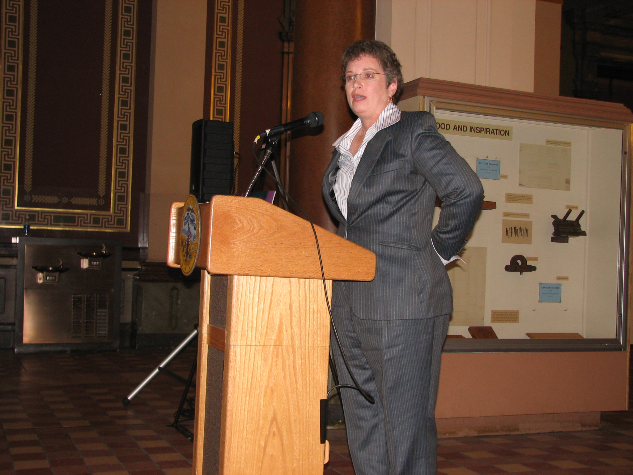
Darwin Larson – Distinguished Service Evelyne Villines and family
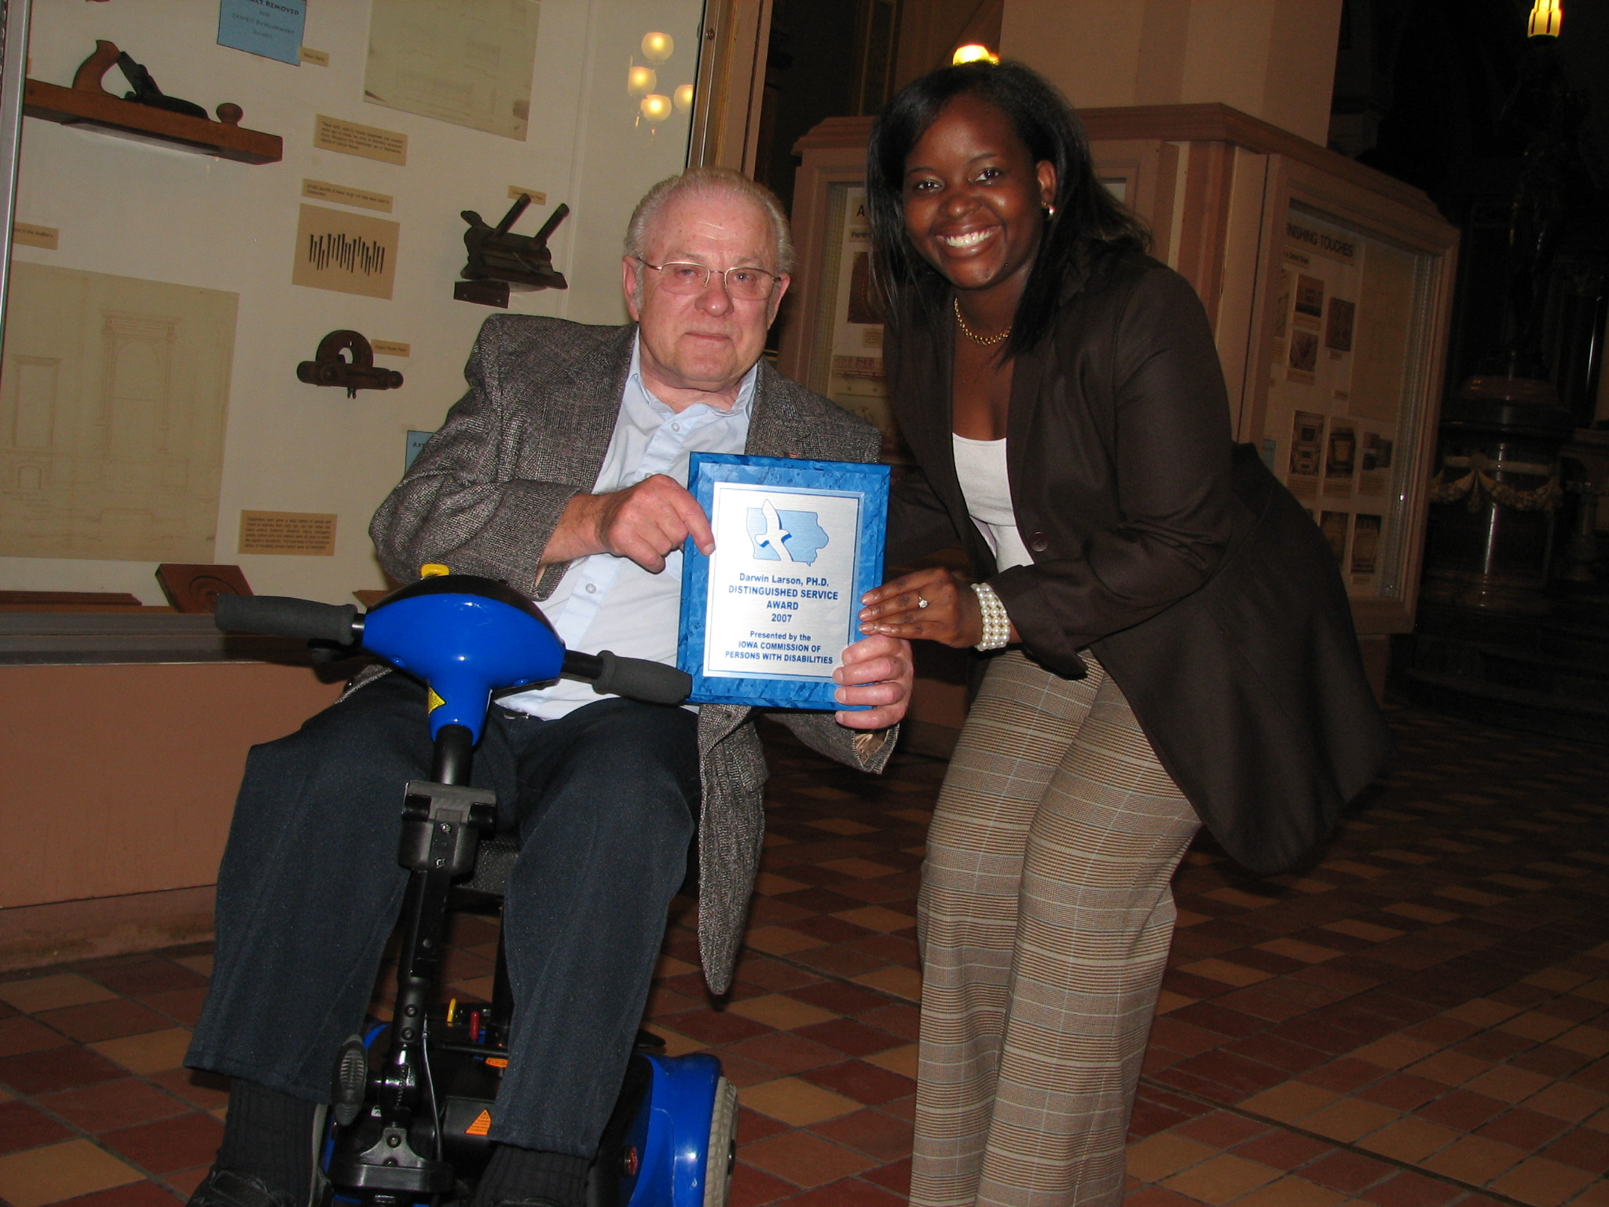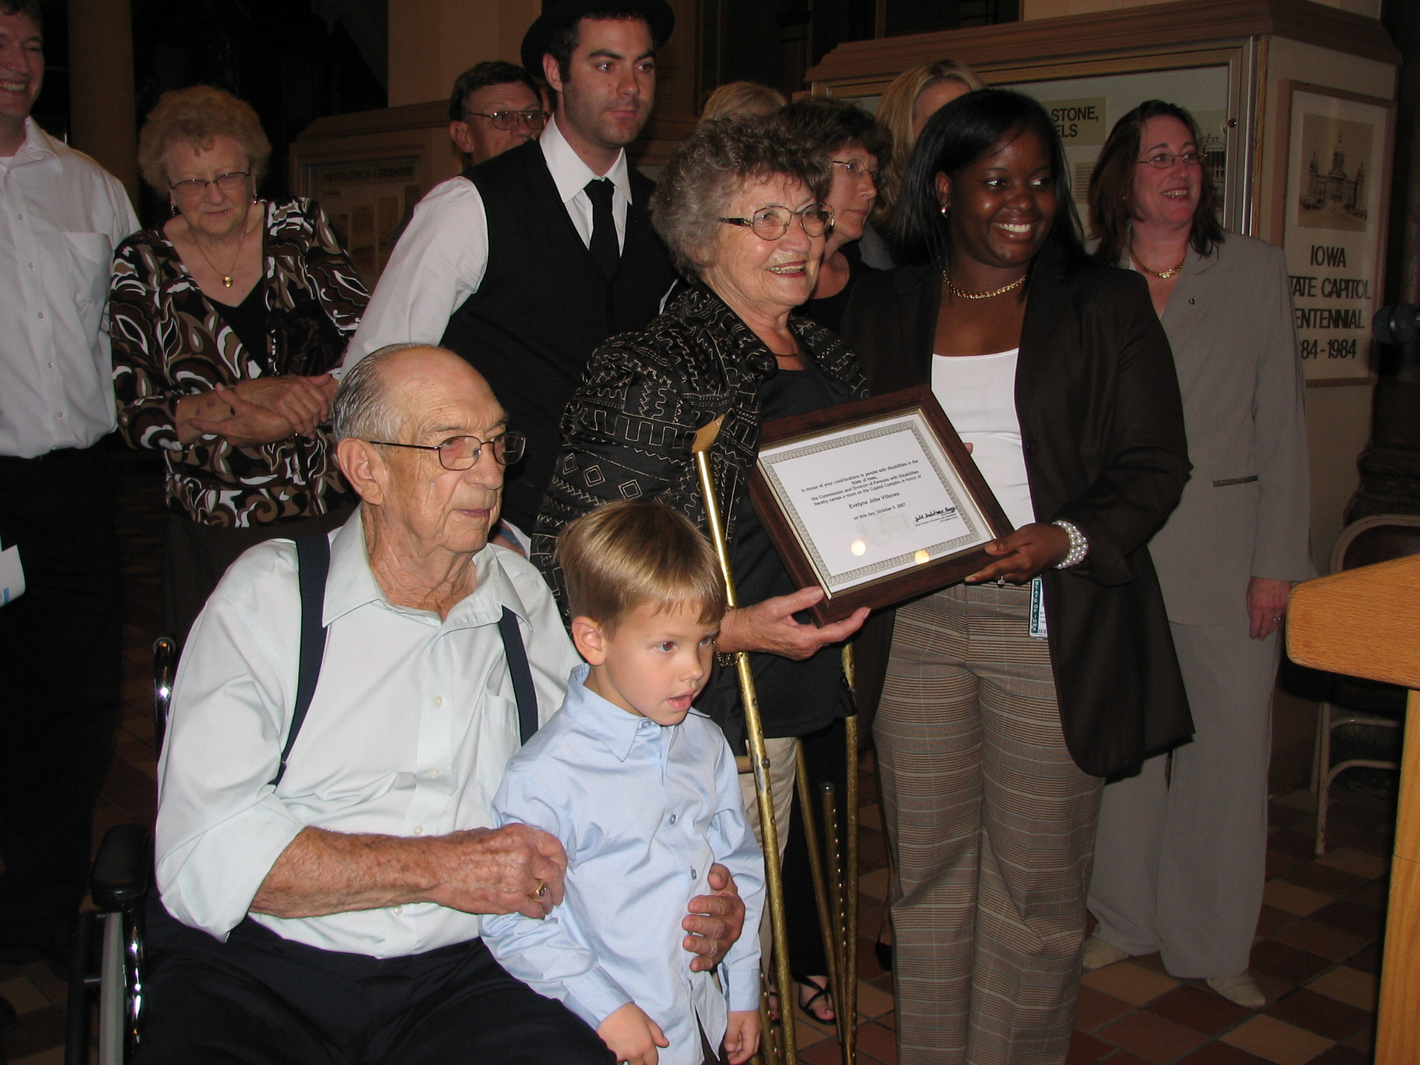
Doreen Rusk – Commissioners Award Kyler Prunty – Youth Service Award
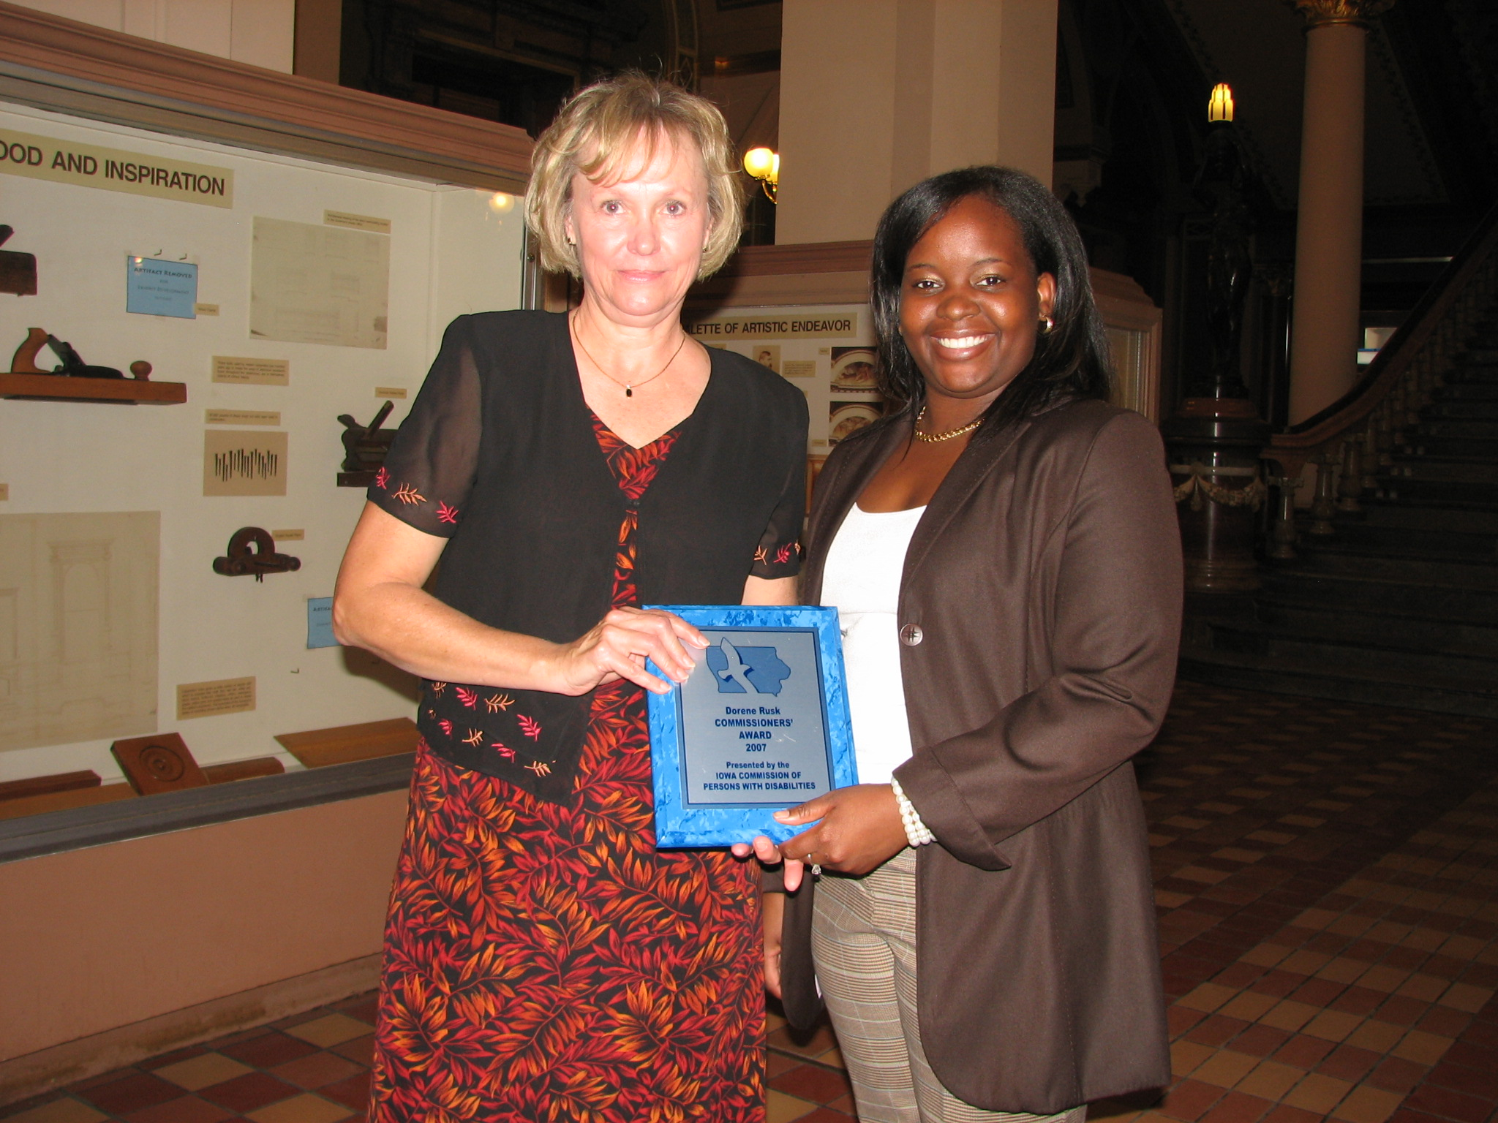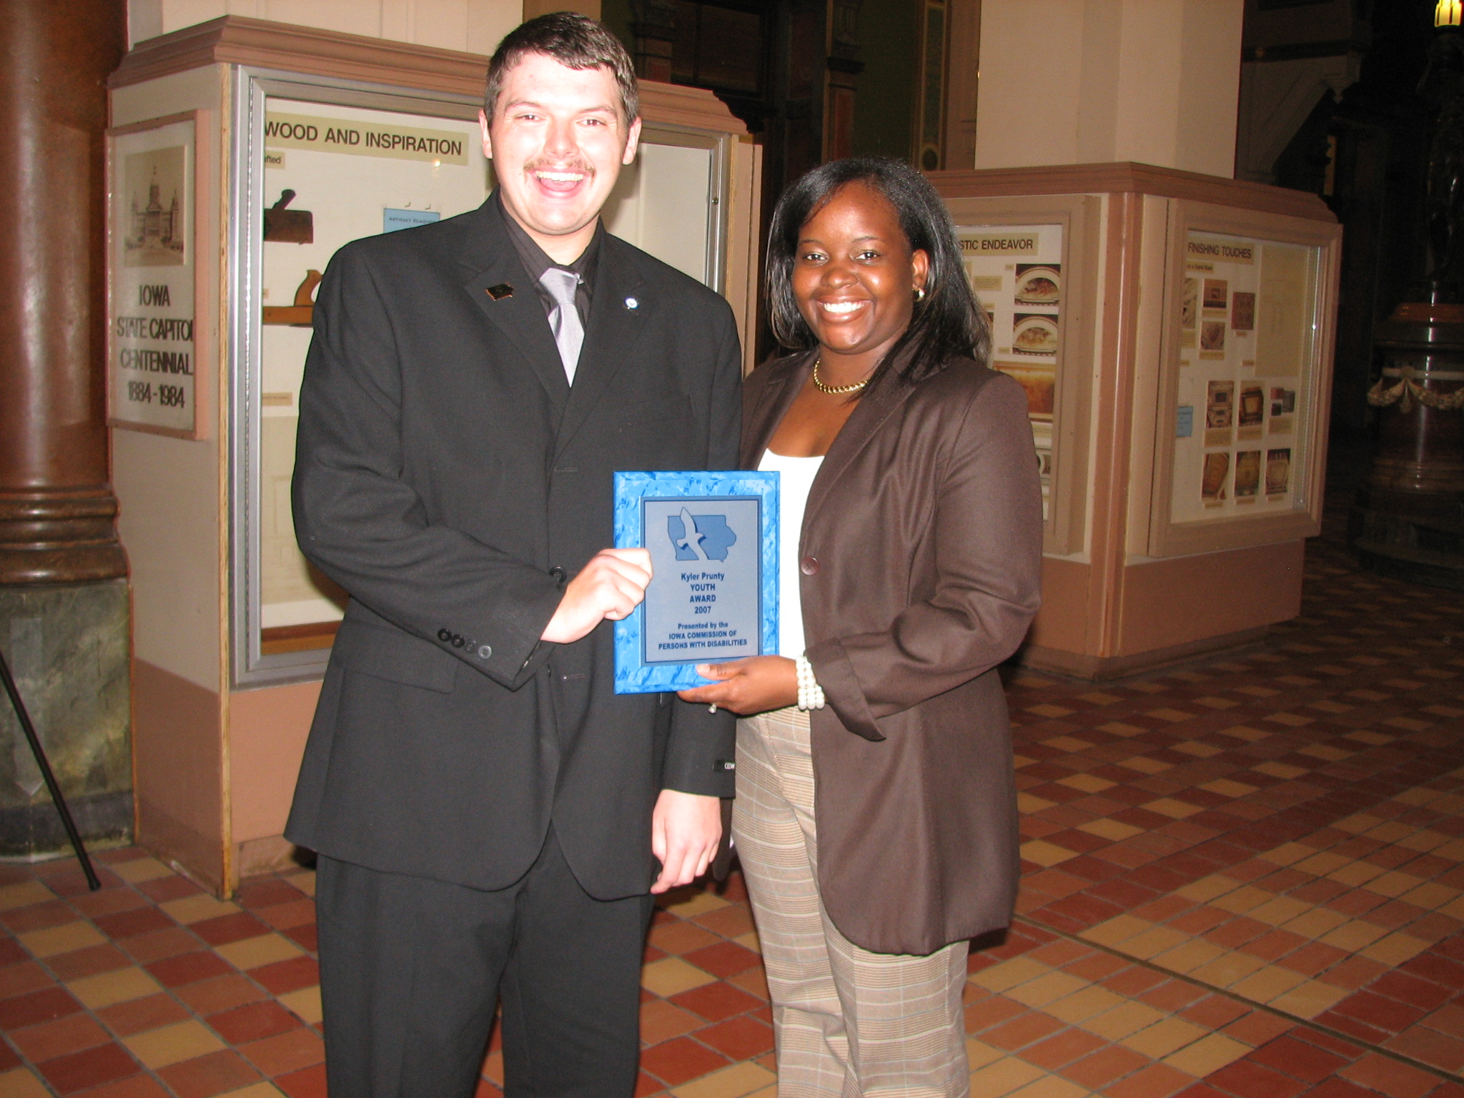
Steve Faulkner – Governor’s Award Quillin’s Food Ranch – Small Employer

Contact Information

Copies of this report may be obtained by contacting:

Jill Fulitano Avery
Administrator,
Department of Human Rights,
Division of Persons with Disabilities
Lucas State Office Building, Second Floor
321 E. 12th Street
Des Moines, Iowa 50319
515-242-6334
Jill.avery@iowa.gov
www.state.ia.us/dhr/pd

What was achieved: Students are satisfied with our services and we exceeded our performance target.
Data Sources: Results of student satisfaction surveys from YLF and CLF.
Resource: .43 FTE YLF and .43 FTE CLF 08 funding

KEY RESULT

SERVICES/ PRODUCTS/ ACTIVITIES

Name: Advocate for applicants or clients to receive appropriate services from the rehabilitation agencies

Description: Percentage of customers resolving disputes through advocacy, mediation and negotiation.

Why we are doing this: Governor Culver’s leadership vision is to enhance the quality of life for all Iowans through a foundation of quality, value and delivery, therefore it is important that appropriate services are provided and disputes are resolved to allow those services to continue.
What we're doing to achieve results: Provide negotiation between agencies or employers and eligible clients for the Client Assistance Program. Investigate and respond to reported inequities in rehabilitation systems and make recommendations.

Results
Performance Measure:  Percentage of customers resolving disputes through advocacy, mediation, and negotiation.  Performance Target:  90% | 100%

What was achieved: No legal action was required to assist individuals in receiving appropriate services.

Data Source: Annual reports of agencies funded under the Rehabilitation Act and audited by Rehabilitation Services Administration.
Resource: 1.8 FTE – CAP 08 federal funding
KEY RESULT

SERVICES/ PRODUCTS/ ACTIVITIES

Name: Iowans are offered information, referral, training and technical assistance on employment, quality healthcare including access to mental health care and substance abuse treatment, independent living, housing, transportation, service animals, and emergency preparedness.

Description: Percentage of customers provided with services.

Why we are doing this: Governor Culver’s leadership vision is to enhance the quality of life for all Iowans through a foundation of quality, value and delivery; therefore it is important that appropriate services are provided to allow those services to continue.
What we're doing to achieve results: Provide information on employment , housing, emergency preparedness, service animals, mental health, access to goods and service, and substance abuse issues, giving information on rights and responsibilities under the Americans with Disabilities Act, the Rehabilitation Act, Family Medical Leave Act, Federal Housing, Help America Vote Act and the Civil Rights Act. Research, attend training, and collaborate with partners to stay current on disability issues

Results
Performance Measure:  Percentage of customers provided with services.  Performance Target:  95% | 100%

What was achieved: Served customers surpassed expectations of staff. Customers were provided with adequate services.

Data Source: Persons with Disabilities database.
Resource: Percentage of all staff and administrator – state 08, CAP 08, 50E8

KEY RESULT

SERVICES/ PRODUCTS/ ACTIVITIES

Name: Educate Iowans with disabilities on rights and responsibilities

Description: Ranking of Iowa among 50 states in employment of persons with disabilities

Why we are doing this: Governor Culver wants to ensure that Iowa has enough workers with the necessary skills to meet current and future workforce needs. Many Iowans with disabilities want to work but do not know resources, rights, and responsibilities relative to training and employment.
What we're doing to achieve results: Provide information on employment , housing, emergency preparedness, service animals, mental health, access to goods and service, and substance abuse issues, giving information on rights and responsibilities under the Americans with Disabilities Act, the Rehabilitation Act, Family Medical Leave Act, Federal Housing, Help America Vote Act and the Civil Rights Act. Research, attend training, and collaborate with partners to stay current on disability issues
Results
Performance Measure:  Ranking of Iowa among 50 states in employment of persons with disabilities  Performance Target:  Top 15 | Iowa ranks 15

